10 QUERY BAGIAN 2

1. SELECT * FROM `pasien` ORDER BY id DESC

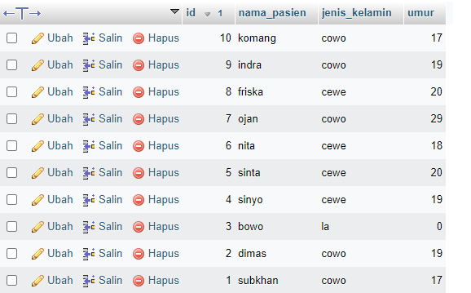

1. SELECT * FROM `pasien` ORDER BY nama_pasien ASC

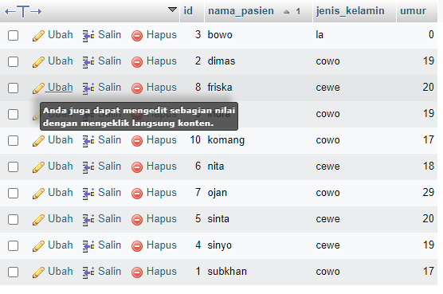

1. SELECT * FROM `pasien` WHERE jenis_kelamin LIKE '%cewe%'

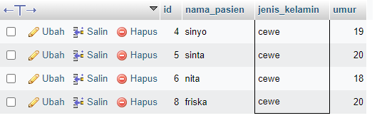

1. SELECT * FROM `pasien` WHERE jenis_kelamin LIKE '%cowo%'

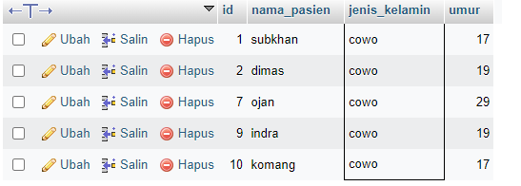

1. SELECT nama_pasien, SUM(id) AS total FROM `pasien` GROUP BY nama_pasien

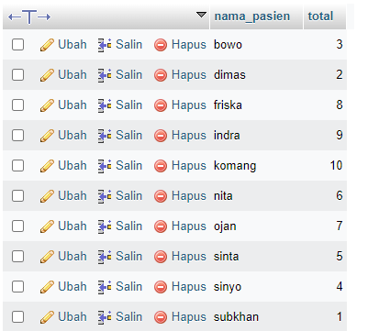

1. SELECT jenis_kelamin, SUM(id) AS total FROM `pasien` GROUP BY jenis_kelamin

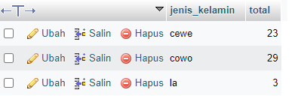

1. SELECT umur, SUM(id) AS total FROM `pasien` GROUP BY umur

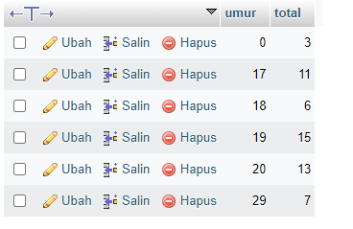

1. SELECT umur, SUM(id) AS total FROM `pasien` WHERE umur>= 15 GROUP BY umur ORDER BY umur DESC

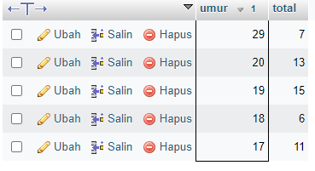

1. SELECT umur, SUM(id) AS total FROM `pasien` WHERE umur>= 15 GROUP BY umur ORDER BY umur asc

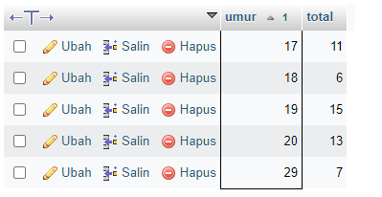

1. SELECT umur, SUM(id) AS total FROM `pasien` GROUP BY umur ORDER BY umur asc

